FACULTY EVALUATION
Programme Name: Social Entrepreneurship Development Program (SEDP)- Start Tanzania Module 3 (2nd February - 6th February 2026)
Session: Sustainability in social enterprise
Faculty Name: Susan Njoroge
No. of Respondents: 18
No. of Participants: 18
Evaluation Parameter | (%) Individual Score | (%) Programme Average
Punctuality (Commencement and Completion of Sessions) | 88 | 95
How well do you understand the core concepts presented? | 87 | 87
Rate your confidence in applying the new skills learnt | 82 | 88
Degree of Faculty preparedness for the sessions | 84 | 91
Content and methodology of the program | 86 | 91
Quality of class and group discussions | 89 | 89
The information presented in the course is relevant to my work (ministry) | 89 | 91
Average scores | 86 | 90

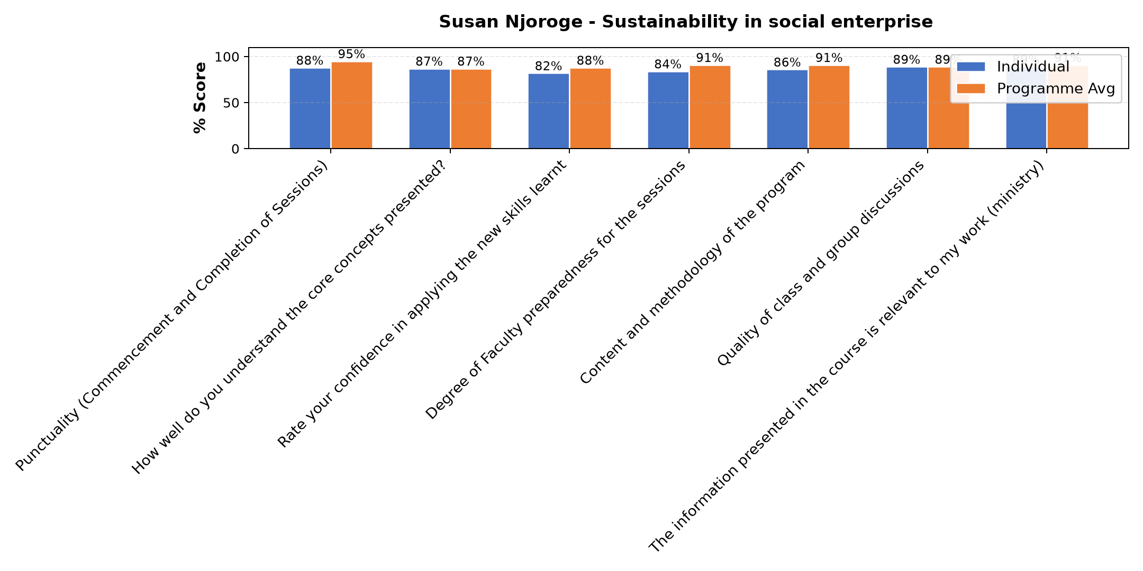

Comments & Feedback
- • Nitajitahidi kutumia elimu niliyojifunza kuinua uchumi kwa shirika na jamii
- • Language
- • Somo lilikuwa zuri nitajitahidi biashara yetu isife
- • Fedha
- • Net work in my social enterprise
- • Climatic change
- • No enough income
- • Lack of proper planning and management makes our activities unsustainable.
- • Nitajitahidi kutumia elimu niliyopata kuendeleza mradi usife
SUBMITTED THROUGH:
SBS Evaluation Automation System

